PileFactory Instructions

Software Introduction
The extraction of traditional pile point design documents is to extract the coordinate and number of pile points from CAD design drawings, which is complicated, time-consuming and has a high error rate. "PileFactory" is an efficient, convenient and highly automated software system for building, extracting and exporting industrial area data for similar projects such as "pile point design and extraction".
PileFactory is an application software based on Windows system that integrates data management, data design and statistical analysis. The main interface is displayed, as shown in Figure 1.
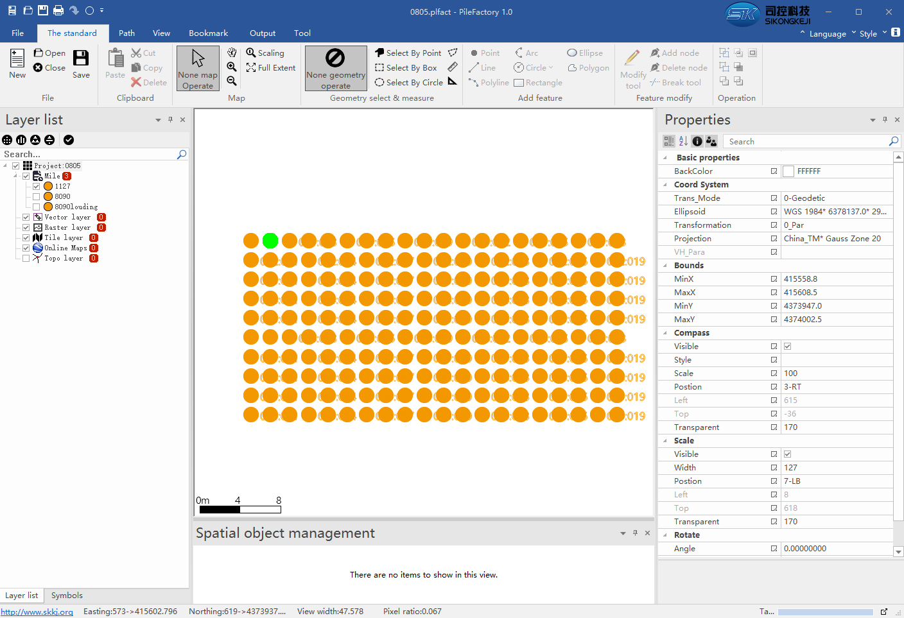
Layer properties area
Element object management area
Data graphics area
Function area
Layer Management area
1

Note: Before using the software, you need to register , otherwise you will not be able to use some functions.
Registration method: Click the button in the upper right corner to enter the "About" interface, as shown in Figure 2. Click "Register" and you need to provide the application code to the software owner. Then he will tell you the registration code. After successful registration, the username will be displayed in the lower right corner of the main interface.
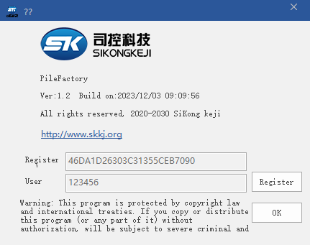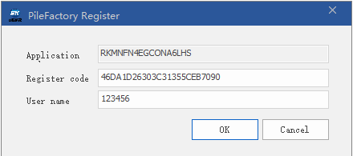
2
The main interface of PileFactory consists of the following parts:
——Functional area:
[file]: Including project creation, opening and saving.
[General]:Concentrates the function keys of data graphics area operation, including adding and deleting points, map zooming in, zooming out, translating, selecting tools, etc., as shown in Figure 1.
[Path]This function is unavailable now.
[View]Set the display and close of the floating window, zoom mode of the mouse wheel, and full-screen display.
[Bookmarks]New: pop up the dialog box of new bookmarks, is to save the current map view in bookmarks format; Manage: Delete and locate the saved bookmarks.
[Output]Output layers.
[Tools]Coordinate system management and online map download.
——Layer Management area.
——Data graphics area.
——Layer properties area.
——Element object management area.
Function area is the Ribbon menu mode. Different Pannel functions are divided into different functions. You can click the arrow near of to show or hide the Ribbon menu.
Except for the graphic data area, other areas are floating Windows, users can according to their own preferences to lift it to any area of the screen, can also be through the option button in the upper right corner of the sub-window for display mode, automatic hide, close and other operations.
Closed child Windows can be displayed through the "View" function page.
Different areas have different functions, which will be reflected in the following description of specific application functions.
The steps to generate project files using PileFactory are as follows:
1. Create a project
Select the  button of "Functional area" to display the new project dialog , as shown in Figure 1.1.
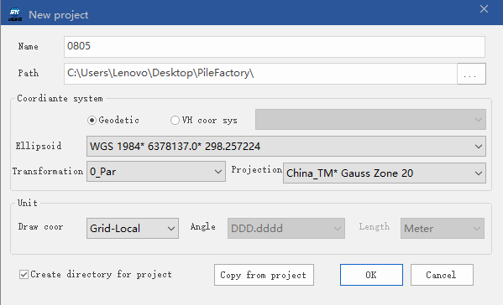
1.1
In this dialog, you need to confirm the following parameters:
——Project name: The name of the project, which need designed in advance and is used to define subsequent data generated against the project.
——Directory: the directory of project data storage. If the directory does not exist, it will be automatically created.
——Coordinate system: PileFactory support point data conversion between different coordinate systems, and supports online map, so to set up the coordinate system.
—— Ellipsoid: The reference ellipsoid used in the project is selected from the drop-down box. If the ellipsoid required by the project is not in the drop-down box, it can be added through 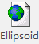the function under the "Tools" page.
——Transformation: The conversion parameters between the WGS84 ellipsoid and the application ellipsoid of the project are selected from the drop-down box. If the conversion parameters required by the project do not exist in the drop-down box, you can add them by using 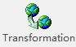the function under the “Tools” page.
——Projetion: The projection parameters. If there is no projection required for the project in the drop down menu, it can be added through 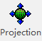the functions on the Tools page.
——Unit: Sets the coordinate system, Angle unit, and distance unit for drawing the map.
The display coordinates of the map should be strictly consistent with the actual coordinates of the data. If you need to convert coordinates, you can right-click on the "Project Name" in the "Layer Management" bar to do so.
——Unit of Angle: currently fixed in decimal degrees.
——Unit of length: currently fixed in meters.
[Create a directory for the project]: Select this option and use "Project name" in the specified directory to create a sub-directory for storing project data.
[Copy from Project]: Select this button to pop up a browsing window, select an existing project and copy its properties over.
After setting the parameters, click the "OK" button to complete the establishment of a project, and open the project as the current project。
2 New Mile
Right-click "Mile" and choose "New Mile" to pop up the New mileage dialog , as shown in Figure 2.1.
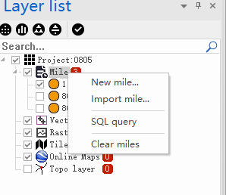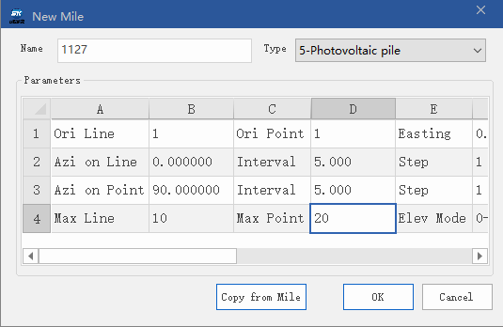
2.1
You need to complete the following parameters in the New Mileage dialog :
[Name]:Support Chinese and English.
[Type]: Pile type, the software contains gravel pile, cement pulverized coal gravel pile, cement mixing pile, spiling, pv, dynamic compaction, deep hole compaction, super dynamic compaction, the static pressure pile, different pile types corresponding to different pile point symbol, which according to the pile point on the map symbol can easily know the pile type. The default is "general", regardless of pile type.
Pilefactory use”row and column”to represent a point position, The idea is that "points that fall within the range of a plane belong to that location.".The following parameters need to be set:
Starting line number and starting point number: the row number and column number of the first point. In the software, the line number and point number are used to represent a point. Generally, the starting line number and starting point number are set to 1, corresponding to the first point.
Easting、Northing: The east and north coordinates of the starting point.
Azi on point: The angle of turning clockwise from the north to the point boundary line.
Azi on Line: Azi on point+/-90°.
Line interval, point interval: the longitudinal and transverse distances of two adjacent points.
When the mileage edge is not a regular rectangle, it is necessary to set appropriate line and point intervals to ensure that each point falls within a separate cell, otherwise there will be repeated row and column numbers.
Point number interval, line number interval: the interval between row numbers and column numbers. Generally, this parameter is set to 1.
Line number length, dot number length: used to define the display format of the row number and column number on the map. By default, three digits are displayed.
Maximum line number and maximum point number: maximum number of rows and columns. These two parameters determine the number of pile points.
See Figure 2.2 below:
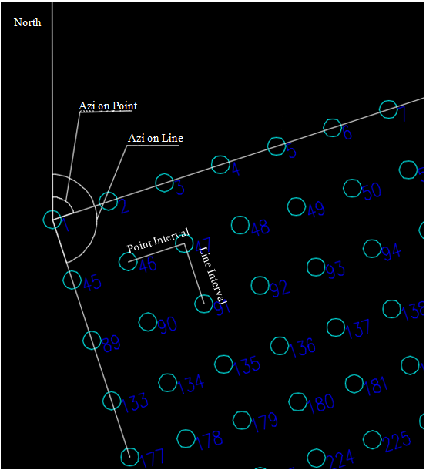
2.2

[Copy parameters]Click the button, the browse window will pop up, select an existing mileage, you can copy its attributes.
[OK]The new mileage is completed, and the new mileage is taken as the current mileage.
[Cancel]Cancel new mileage.
3 obtain mileage data
There are two ways to build mileage data, one is to design the data in the software, the other is to extract the data from the files (DXF format CAD files, shape files, etc.) containing the coordinates of pile points, pile number and other information, and generate mileage data files. The following uses new mileage as an example to illustrate the realization process of mileage data.
Method 1:use the software to generate pile point datas
Find the mileage file under the mileage layer, right click "pile points design", and pop up the pile point design dialog box, as shown in Figure 3.1.
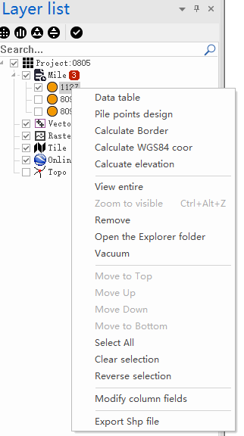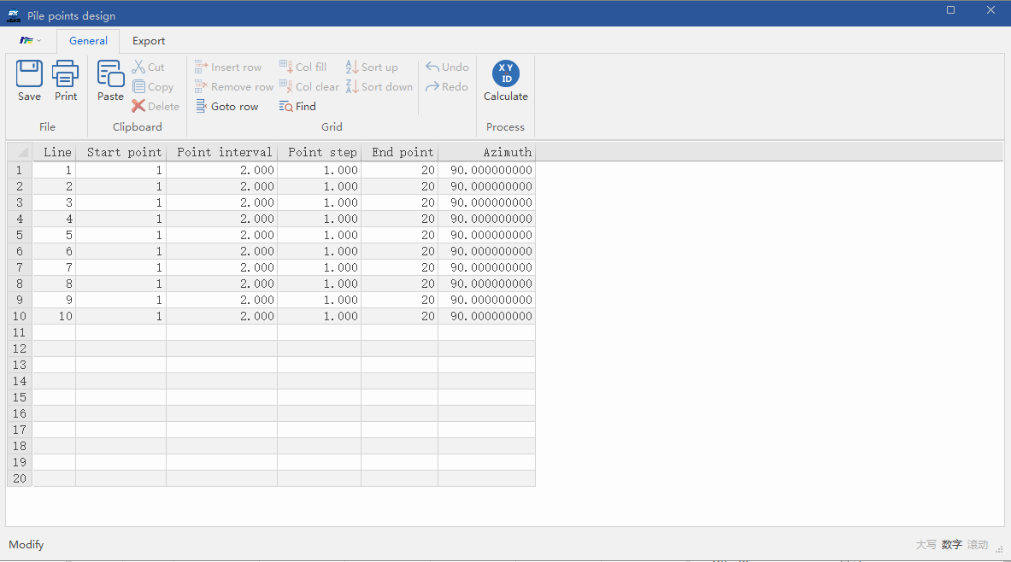
3.1
The function bar is not enabled by default. Click any position in the table to restore the function bar to the enabled state. In the enabled state, you can edit the design table file.
The default display in the pile points design table is the extracted point number, line number, orientation, and other information based on the parameter settings of the new mileage. Users can add or delete line numbers or point numbers in the table according to their needs. After the design parameters are confirmed, click the function area [calculate], and the software will automatically calculate the pile data. Then you can see the pile graph in the main interface. as shown in Figure 3.2:
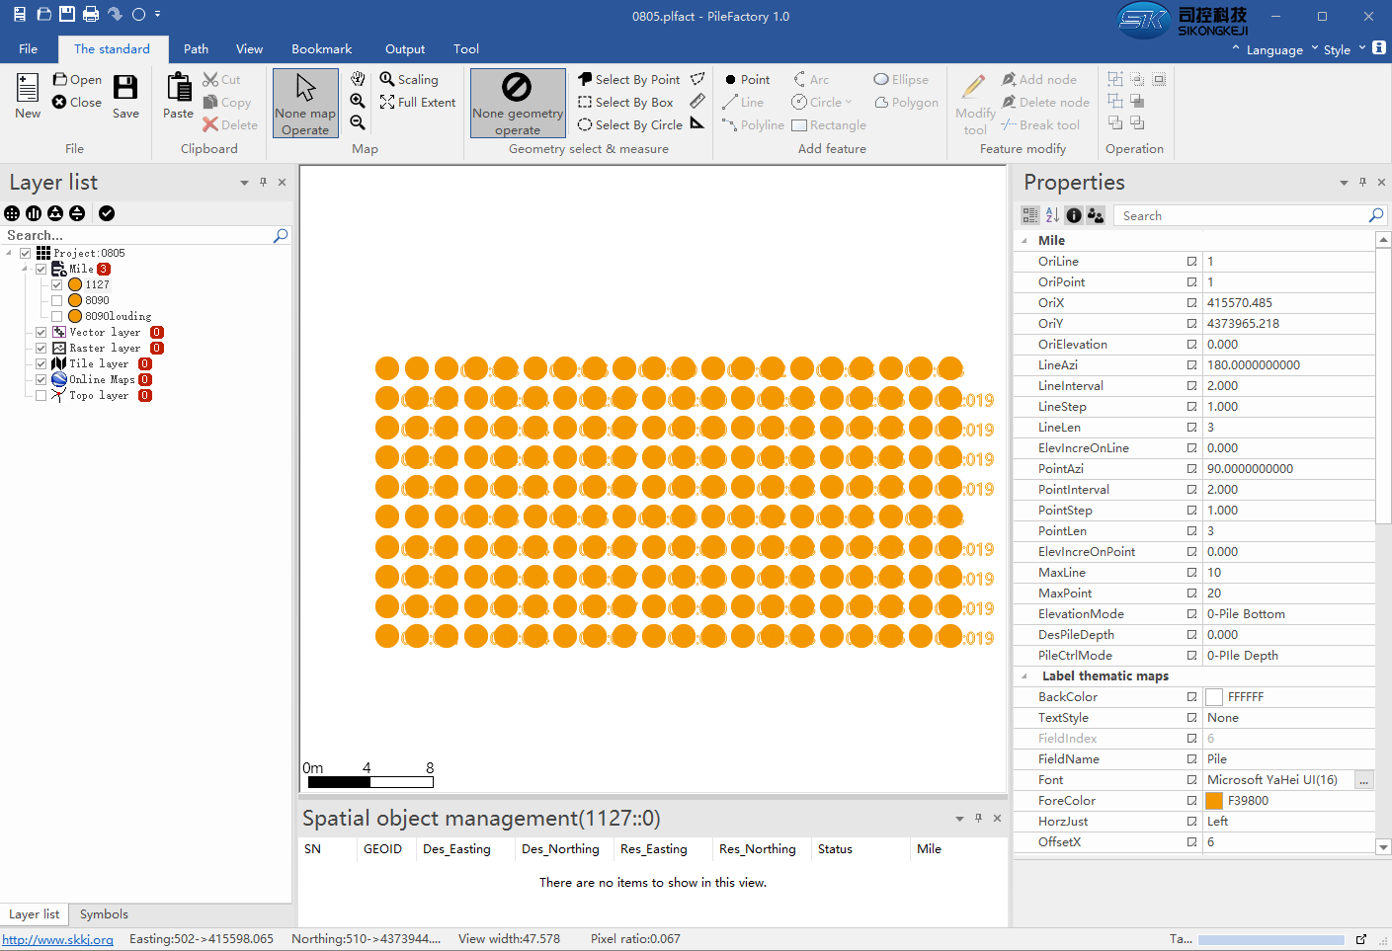
3.2

Right-click on the mileage name and select "Data table" ,as shown in Figure 3.3.
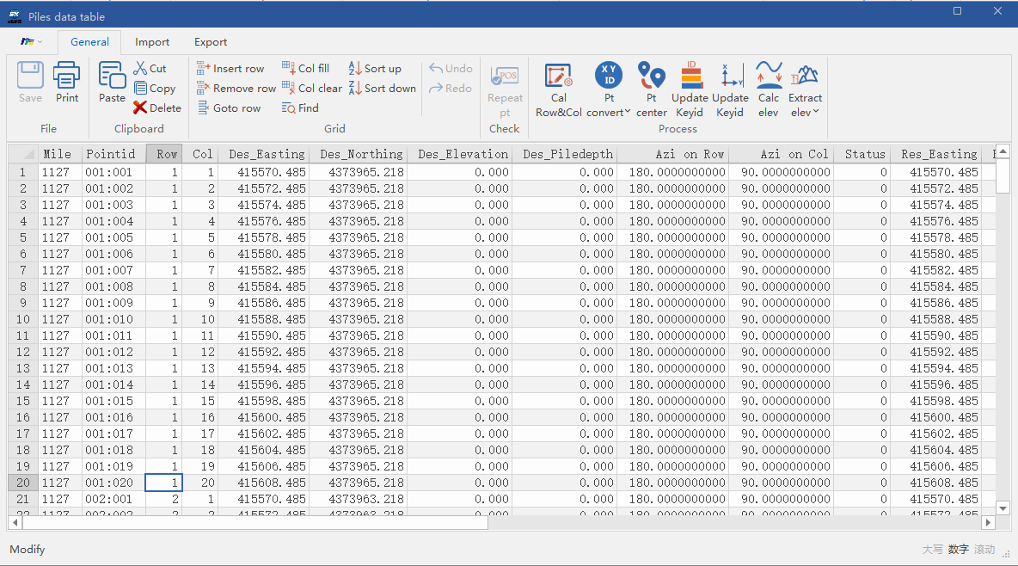
3.3
Key parameter :
[Cal Row&Col]When generating design data, the software will automatically calculate the row and column numbers of pile points based on project parameters, and usually there is no need to recalculate.
[Pt convert]There are two ways to display the pile number: serial number (1, 2, 3...) and column numbers (1:1, 1:2...), this button to realize the switch of two display modes of pile point number.
[Pt center]The design concept of the software is "all points fall within the range of a surface element belong to this position" , usually there is no need to perform this operation .
[Calc elev]Calculated elevation.when the value of Elev Incre is not zero,you can get the elevation of each pile by the button.
Method 2: Import the pile point data file
The software supports extracting pile point information from SHAPE file and CAD graphics file (DXF format). Right-click the mileage file and select "Data Table", and select "Import" in the shortcut access bar of data table, as shown in Figure 3.4:
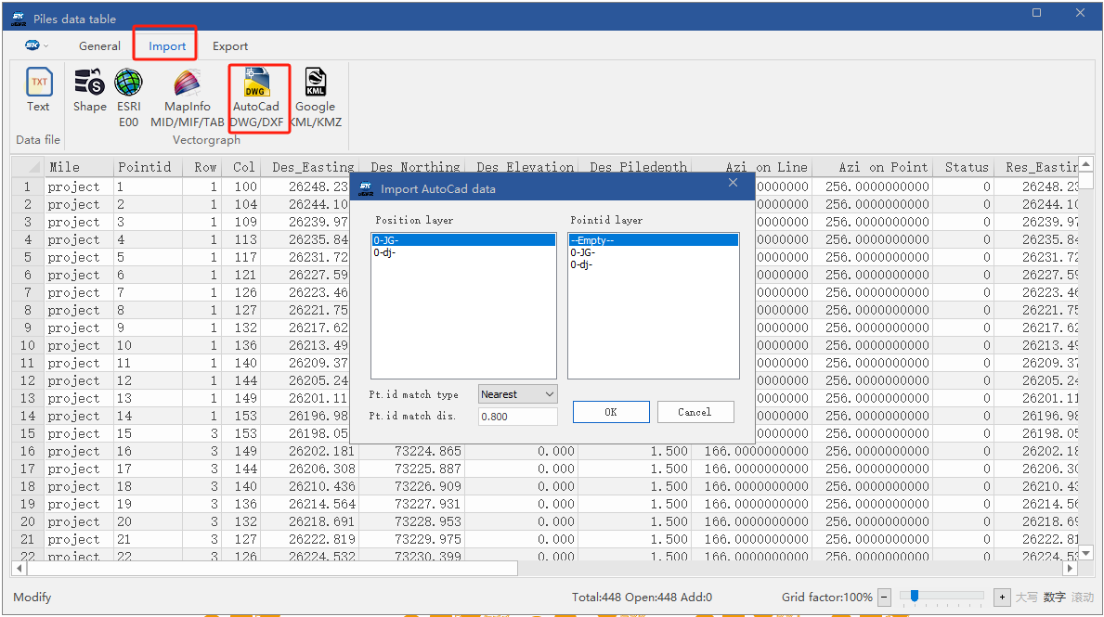
3.4
There are two methods to match the point and point number:Nearest and Keyid.
Nearest:you need enter the matching distance(Pt.id match dis.),in this distance ,the system will match the nearest ponit number to the point.
Keyid:match the point and point number by Keyid.
Both the metheds, the Keyid number must not be repeated.
If there is data in the data table, the newly imported data will not overwrite the original data, You can select the whole table by clicking the "triangle button" in the upper left corner of the table, and click the "Delete" key in "General" to delete the table data file and import a new data file.
When importing data from CAD, the CAD file format must be in dxf format, and the layers of the CAD file should be as simple as possible, including only graphic layers and station layers. Other excess layers can be deleted.
Whether the pile point data is calculated by software or imported from CAD files, there is only the east and north coordinates of the pile point at this time, there is no longitude and latitude information, so it is necessary to calculate the longitude and latitude information of the pile point. Right-click the mileage, select "Calculate WGS84 coordinates", pilefactory will calculate the longitude and latitude of the pile point according to the coordinate system set by the project, and enter the mileage - data table again, the calculated latitude and longitude can be seen in the column of Geodetic latitude (WGS84) and geodetic longitude (WGS84).

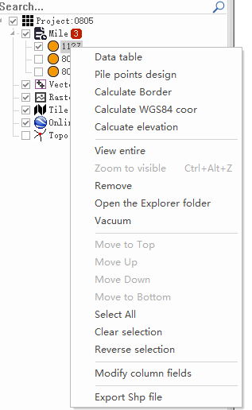
3.5

Note:
1. If the project file is applied to the pile machine software, the blank layer should be used. Please do not load vector layer, raster layer, tile layer, online map, topology layer and other layers in the project, otherwise the map display may be inaccurate when the project data is loaded by the pile machine APP.
2. When importing data from CAD files, the distribution of pile points in the original file should be regular. This software does not currently support the extraction of pile point data with irregular distribution.
4 Application of project and mileage files
After the project and mileage data are established, a folder named after the project name will be generated in the storage directory of the project (the storage path of the project when creating a new project), which contains *.plfact(project file), *.sym(symbol file) and *.mile (mileage file), as shown in Figure 4.1. Copy the entire project folder to the tablet where the pile machine software is located, and load it in the APP.
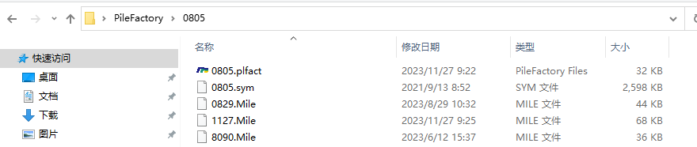
4.1

